**Advanced Social Phycology**

**Social Media Campaign**

Table of Contents

1.0. Introduction 2

2.0. Social media campaign 3

3.0. Name of the proposed restaurant 5

4.0. Focus on Health and fitness 6

5.0. Focus on fostering customer engagement 8

6.0. Ask for Reviews & Ratings 8

7.0. Offer “Daily Deals” 8

8.0. Video Advertisements 8

References 10

# Introduction

Social psychology is referred to as the field that study the process of thinking and feeling of the people. It is believed that the feeling and behavior of people are significantly influenced by the illusory, actual and implied presence of others. Thought process of a person defines the possible action of that person. If thought are influenced or modified, they will be reflected through the subsequent actions of a person (Higgins, 2015).

Organizations nowadays are engaged in marketing through different means, the aim of all the advertisements and promotional activities initiated by organizations is to make people think their way. Marketing is undergoing through a substantial evolution in the contemporary world and new ideas and innovations are being included to enhance the customer base and to maximize the profitability of the company (Barker, 2011).

Among other marketing strategies, social media is one of the latest and effective one. Social media marketing is redefining the business due to its great tendency of influencing the minds of the customers. It has considerably changed the way people see the world. The significant impact of the social media on consumer behavior has compelled the companies to use it for the promotion of their products and services. It is argued that social media platforms are maturing into serious communication channels for both SMEs and large enterprises. Consumers are increasingly adopting social networking, engaging in micro-blogging and downloading applications for smartphones and tablets. Along with sharing and communicating with friends about their social lives, updating pictures and posting status updates (Zarrella, 2015).

Social networks are ideal for creating and encouraging brand loyalty and effective customer-to-customer based information and discussion exchange. Marketing on social media platforms is a huge topic of interest at the moment across different organizations worldwide. It is still relatively a new concept with regards to marketing, therefore generating much uncertainty about how great an impact it will have on the growth and expansion of a company. Statistics have shown that young people nowadays spend most of their time on different social networking sites. The wide used of social media unleashes the extensive opportunity for organizations to influence their minds and attain desired results (Deborah, 2013).

This study is aimed at designing a social media campaign for the promotion of newly established organic food restaurant. This restaurant will provide organic food that is considered healthier than fast food in the UK. The social media campaign will involve different advertisements that will be intended to entice customer to purchase organic food from this restaurant.

Impact of social Media on Customer’s

# Social media campaign

Facebook is the most active social media platform there is. Their page has regular posts and interactions with their current and potential customers. It can be seen from the screenshot taken from the F.I.T. Buster page that the page is growing weekly with regards to the number of likes it is receiving. The page has multiple ‘thank you’ posts from current clients, expressing their gratitude after their training session at the studio. These posts are valuable for F.I.T. Buster’s as they’re likely to catch the eye of any potential clients, researching the service (Levinson, 2013).

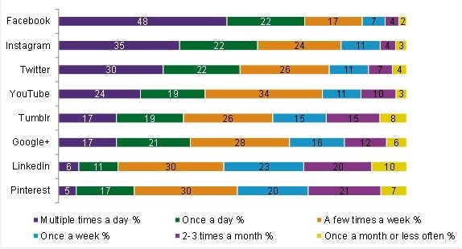

Figure 1: Social media usage in the UK, source: (Deborah, 2013)

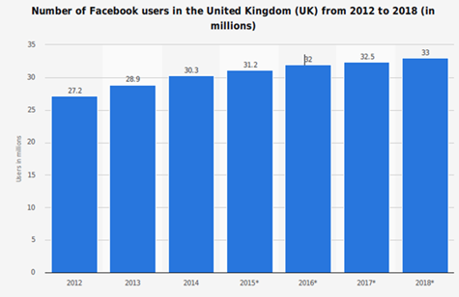

Figure 2: Number of Expected Facebook users in the UK, source: (Barker, 2011)

The above graph shown that the Facebook users in the UK are increasing with the passing year. This provides an attractive opportunities to the companies to target large amount of marketing with cost effectiveness. Throughout Facebook’s promotional materials, the benefits of using their platform are clearly set out. Customized news feed based on users’ personal information, interactions, which indicates what they may like (Barker, 2011).

* Brand recognition is a self-explanatory term which means that you are standing at huge public platform, where everyone is focusing your product which in returns build brand image.
* Facebook is one of the popular social media platforms which are used for publicity and brand awareness through which website visitors can easily become your fan and follow your business page.
* Effective brand monitoring helps the organizations to counter misconceptions or opinions about your company by directly addressing them.
* Increase search engine rankings because all data can be made public so by using major brand key words a company page can come up on top on Google etc.

# Name of the proposed restaurant

Researches have shown that name plays an important role in advertising of brands, it should be attractive, simple and easy. The chances of the success are doubled if the name of the business is intriguing. The name for the proposed restaurant will be “Core of the Health Organic Restaurant”

# Focus on Health and fitness

The social media campaign will focus on the theme that will attract the customer towards organic food. Researches have shown that men like thinner women as their mind perceive fit women as more beautiful and fertile (Burke, 2007). The advertisement that will be run on the social media will focus on the positive impact of organic food on obesity. A study conducted by the University of Aberdeen found out the men use fitness to determine which women is appealing or which is not. Fast food is widely associated with the obesity and overweight and the research have shown that the people facing obesity problems and 27.1 percent people suffer from this problem (Dunn-Georgiou, 2006).

Professor John Speakman who coordinated the above mentioned study said” 'What we wanted to investigate was the idea that when we look at someone and think they are physically attractive” (Douglas, 2013).

Below graph shows the correlation between body mass index and attractiveness rating. These type of researches will be used in the advertisement in order to influence the mind of people toward organic find and

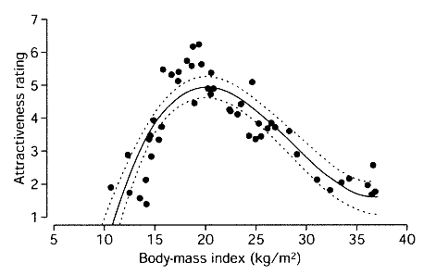

Figure 4: Correlation between body-mass index and Attractiveness, source: (Canavari, 2016)



Figure 5: Propose layout of the Social media page of the Organic Restaurant

The above picture subliminally depicts that if you eat organic food, you will likely to be healthier. As it is discussed above that people want to look smart and slim, this add will surely capture their attention

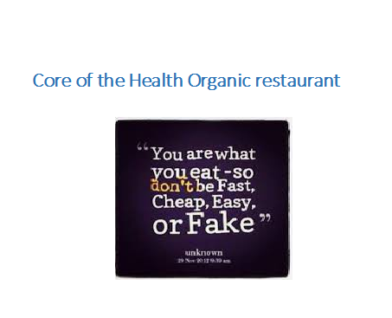

Figure 6: Proposed slogan

# ****Focus on fostering customer engagement****

It has been that if customer are provided with the opportunity to give their opinion regarding the quality of product and services, they are more likely to attract towards the product. In the proposed social media campaign, there will be an option where customer can give their opinions to enhance the quality of the restaurants. It will have a strong impact on customers mind. They will feel that they are being taken care of and they have a stake in the decision making process of the service provider. This would not cost much to the “Core of the Health Organic restaurant” but it will have a long lasting impacts on the psyche of the customers.

# Ask for Reviews & Ratings

Official pages will be created on different social sites and customer will be asked to review the services and rate different products that are being offered at the core of the Health organic customer.

# Offer “Daily Deals”

This promotion will be specified for the social media users. In this promotions, the customer will be asked to sign up the page of the Restaurant and a luck draw competition will be undertaken. The customer who will win the lucky draw will get the free mail for that day. This will surely have a great impact on the customer mind. Nothing comes free in this world. Reports have shown that customer are likely to be attracted by discounted deals and offers.

# Video Advertisements

People are usually more inclined towards the online video. The survey showed that people spend most of the time on watching different online videos.

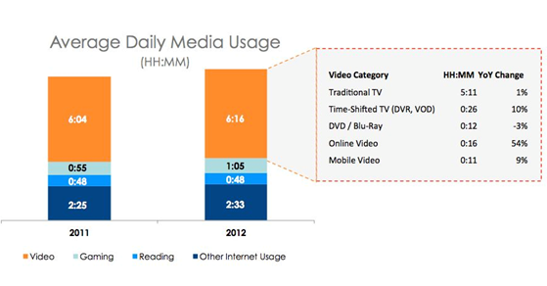

Figure 7: Social Media Survey

It has been observed that people are more attracted by the video advertisements rather than outdoor marketing. This proposed social media campaign will include the video in the campaign and that video will be posted on the different social media platform. The content of this video will be prepared with immense causticness and will have subliminal messages in order to attract the customers. In this video the researches regarding harmful effect of fast food will presented with fact and figures. The video will start with the girl having burger in her hand, that girl will be overweight and deformed. A guy will apparently approach her and will say to her “This relationship is getting “heavier” on me” and will leave the restaurant. The next scene will show that the same man is entering into the Core of Health organic restaurant, a girl with perfect weight and shape will be waiting for him. He will come sit beside her with smile on his face. The girl will be holding a menu card showing organic foods. At the last of the video, the message will be displayed on the screen showing the message that “Give up being a fast, until it gets too late”. This video contains several subliminal messages that are likely to attract wide ranges of customers.

# References

Barker, D. I., 2011. *Social Media Marketing: A Strategic Approach.* London: Routledge.

Burke, C., 2007. *To Buy Or Not to Buy Organic: What You Need to Know to Choose the Healthiest, Safest, Most Earth-friendly Food.* London: Routledge.

Canavari, M., 2016. *Organic Food: Consumers' Choices and Farmers' Opportunities.* Lonodn: Pearson.

Cox, J., 2013. *The Organic Food Shopper's Guide.* London: Kogan Pages.

Deborah, 2013. *Social Media Marketing All-in-One.* London: Kogan Pages.

Douglas, K., 2013. *Social Psychology.* London: Routledge.

Dunn-Georgiou, E., 2006. *Everything You Need to Know about Organic Foods.* London: Willey.

Henderson, 2015. *The Truth about Organic Foods.* London: Wiley.

Higgins, E. T., 2015. *Social Psychology: Handbook of Basic Principles.* London: Willey.

Levinson, J., 2013. *Guerrilla Social Media Marketing: 100+ Weapons to Grow Your Online Influence.* London: Rouledge.

Zarrella, D., 2015. *The Social Media Marketing Book.* London: Willey.