**TRAINING PROGRAM**

*(A case study of MRSA infection)*

Name of the Student:

Name of the University:

Authors Note:

**Table of contents**

Introduction 2

Rationale of the training program 2

Theories 3

Evidence 7

Responsibility matrix 8

Training program 9

References 12

# Introduction

There are numerous disorders prevalent in our society. Depending on the immunity of individual, they get infected or escape the infection. The infections of diseases can be different types of viral infection and bacterial infection. Here in this brief opportunity of study, the chief focus will be on the infection in the human physical system caused by ***Methicilin Resistant Staphylococcus Aureus (MRSA)***. These bacteria commonly found on the human skin and nose of the healthy people and have tremendous potential to infect the fresh human physical system. However, the chance of the MRSA infection gets higher when the individual is in the immune-compromised situation. This can arise due to disorders like AIDS or during the treatment of the diseases with immune suppressive drugs. These are chiefly used in case of transplantation and surgical approach. Hence, it is paramount to make possible awareness among the medical staffs while engaging them in a training schedule. The key aspects of the training program are a generation of the candid medical policy for the MRSA treatment and prevention. Secondly, anther aim is to achieve the safe and healthy environment. The third aspects of the training program are to garner the adequate knowledge regarding the practical skills of the medical staffs to get them equipped with the technology to prepare a functional workforce and better treatment of the patients in general.

The entire training program has been conducted and organizes in the 5-day workshop process. In this assignment delegation of the work responsibility and the required medical kit has been supplied as well.

# Rationale of the training program

***Significance:*** Staph Aureus is the type of bacteria which is having greater resistance power towards antibiotic treatment. However, the MRSA can be described as the strain of the staph aureus which cannot be treated with methicillin anymore which has become methicillin resistant, as mentioned by Stevens, Parimon and Bryant, (2016). Now, in hospitals there are several types of the patients may come for their treatments. It is entirely possible that some of them are in their immune compromised situation. Then, during that phase of the patient they can get infected by MRSA and depend on the severity of the infection, it can lead to death as well.

***Focus:*** During this training program the chief objective will be generating proper awareness regarding the diseases while equipping the medical staffs like nurses, matrons, and midwives with the prevention, diagnosis, and treatment-related aspects.

***Location:*** This training program has been conducted at the Navy Hospital, Devonport. This is a government operated hospital situated in the Auckland region of New Zealand specialty area for Navy forces.

***Stakeholders:*** In this particular training program the medical staffs including the nurses, midwives and the trainee doctors are the core internal stakeholders along with the patients. In contrast, the legislative authority and the stat board of the medical health, in New Zealand is the external stakeholders of this particular training program.

# Theories

***ADDIE Model***

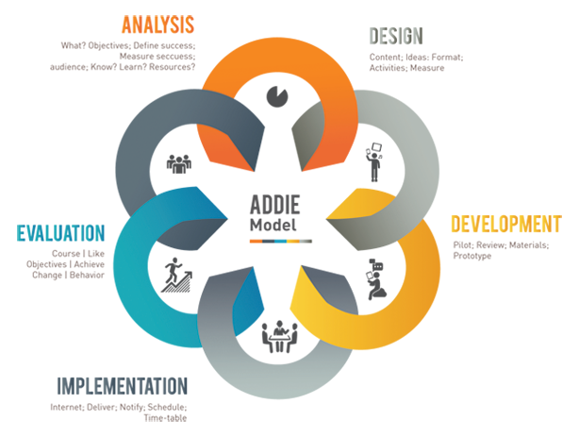

***Figure 1: ADDIE model***

(Source: Lu, Cheng & Chan, 2016)

This particular model was redefined by Dick and Carey following the generation stage in an earlier time. This specific model has five different steps which may help in a systematic learning process. They are described below in brief in context of the present training program:

*Analysis:* In this stage, the designer strive to understand the fundamental situation and endeavor to generate the specific training schedule for the intended deployment of learning purpose. Thus, in this case, it will be important to describe the MRSA infection to the learners and the critical situation that may arise due to the MRSA infection. The following stage will be the analysis of the understanding level of the staffs regarding this disorder and help them to bridge the gap in their knowledge through the training procedure.

*Design:* This step involves the prototype designing, as mentioned by Lu, Cheng, and Chan, (2016). This can be done while making detailed structures of training schedule and generating awareness regarding the training needs among the medical staffs in the hospital.

*Development:* This particular step involves the preparation of the learning objective and the study materials. In this context of the MRSA training facility in Navy Hospital, Devonport, providing the hands-on training for the practical session can be described as the part of this step beside the theoretical lectures on the diseases and their implications.

*Implementation:* As opined by Kang, (2015) during this phase the hands-on training are being deployed, and the learners try it as well. In this case, the medical staffs will do the minute hands on process to learn the MRSA detection and the cure-related aspects.

*Evaluation:* This final step of the model where the learning regarding the particular subject is being evaluated through small questionnaire and the concluding discussion. In this case, this step will help in understanding the implication of the training and the possible gaps which need further improvement or more hand son practices ion future for dealing with MRSA infection.

**Situated Learning Theory**

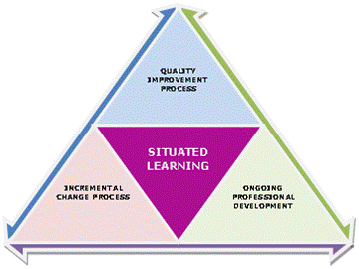

**Figure 2: Situated Learning Theory**

(Source: Hou, 2015)

According to thismodel, learning is an unintentional process, and the mostly depends on upon the “*legitimate peripheral participation”*. It is based on the social settings and the environment in which the learning is being conducted. Thus, in this case, it can be mentioned that the training model has involved the entire staffs of the organization reghar5dless of the degree and expertise. Thus this general training approach regarding MRSA identification and treatment can be helpful in deploying the full benefit of the training in general for better impact on a mass scale.

**Bloom taxonomy**

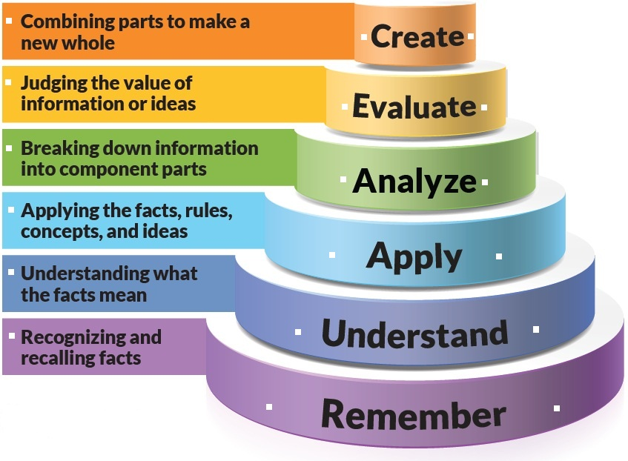

**Figure 3: Bloom Taxonomy Model**

(Source: Tao, 2016)

According to this specific model of Bloom Taxonomy, the approaches have been defined explicitly. As per this model the creation of knowledge is the first step which is done through the power point presentation of the slides regarding the detailed discussion of the disease MRSA infection. The following steps are the analysis of the disease and application. This has been designed in the part of practical hands-on training. The understanding part has been followed by the discussion made on the hands on process and question-answer session. For the compliance of the last part of the model, extended 16hours training has been given as the option to the learners for annual certification on the MRSA case handling. This approach will help them to remember the training methods and will helpful in dealing with MRSA infection in future.

# Evidence

**ADDIE Model:**

***Theorist name:*** Dick and Carey

According to this model, training has been initiated with the analysis of the disease through the power point based presentation given by the experts. In the following step hands on the process have been started which have helped in designing the analysis of the disease and development of the proper idea regarding identification which has assisted in the implementation phase. Finally, the evaluation phase has been conducted through the question-answer session and proposal for the extended training program. This model can be mentioned as the primary step in the entire learning process, as described by Kang, (2015), and MRSA training is not an exception.

**Situated Learning Model:**

***Theorist name:*** Jean Lave

As per this theory, the entire program has been conducted while targeting the medical fraternity and the staffs, which is imperative for the overall better deployment of the knowledge.

**Bloom Taxonomy:**

***Theorist name:*** Bloom

In this theory, the applications related aspects have been given prior importance. This has been addressed through proper evaluation and appropriate assessment of the result analysis issues from the individual end. Moreover, the idea of extended training for annual certification also corroborates the approach described in this particular model of learning which will help in remembering the training for future needs as well.

# Responsibility matrix

|  |  |  |  |  |  |  |
| --- | --- | --- | --- | --- | --- | --- |
| **Training program** | **MRSA Training Program** | | | | | |
| **Task** | **Students Name** | | | | | |
| **Student 1** | **Student 2** | **Student 3** | **Student 4** | **Student 5** | **Student 6** |
| *1. Preparation of report* |  |  |  |  |  |  |
| *1.1 Introduction of the topic* |  |  |  |  |  |  |
| *1.2 Significance* |  |  |  |  |  |  |
| *1.3 Evidence* |  |  |  |  |  |  |
| *1.4 Formatting APA structure* |  |  |  |  |  |  |
| *2.Matrix determination* |  |  |  |  |  |  |
| *3. Arranging the meetings* | 01/09/2016 | 02/09/2016 | 03/09/2016 | 04/09/2016 | 05/09/2016 | 06/09/2016 |
| *4. Initiation of the training program* |  |  |  |  |  |  |
| *4.1 Pre-training process* |  |  |  |  |  |  |
| *4.2 Identification of goals* |  |  |  |  |  |  |
| *4.3 Determination of the learning objectives and outcomes* |  |  |  |  |  |  |
| *4.4 Development of the contents* |  |  |  |  |  |  |
| *4.5 Deployment of the training* |  |  |  |  |  |  |
| *4.6 Evaluation/Assessment* |  |  |  |  |  |  |
| *5. Concluding section with hands-on kits distribution for future practices* |  |  |  |  |  |  |

**Table 1: Responsibility Matrix**

(Source: Created by author)

# Training program

**Introduction:** In this project, we are trying to provide the training to the medical staffs who are handling the patients on the daily basis at the Navy Hospital Davenport. In this case, the experts from the residential care facility (RCF) which follows the guidelines of Infection Control Standards NZS 8142:2000 (Standards New Zealand) and authorized by the Ministry of Health, New Zealand, are providing the hands-on training.

In order to run this project successfully, we are striving to make possible training charts and the arranging the training materials as well for the successful training program. This includes the hands-on kits, projectors, slides for the powerpoint presentation and venue management.

**Pre-training:** Before the commencement of the actual training regarding the MRSA infection control it is important to describe the disease and its implication among the medical staffs. Thus, we have arranged the pre-training lecture schedule by the experienced doctors regarding the MRSA infection and helped them give the presentation while providing them the subject materials in power point slides. The transmission of the disease and the possible identification techniques has been described by the experts in the pre-training classes.

**Goal:** The chief purpose of this training program is to build comprehensive knowledge among the medical staffs regarding the MRSA infection and the possible ways to deal with the disease in a professional manner. Additionally, the accuracy, safety, and reliability of the process have also been strived to incorporate in the training process.

**Learning objectives:**

* To help the medical staffs to gain knowledge about the MRSA infection
* To develop the understanding regarding the speared, identification and control of the disease.

**Learning outcomes:**

*General:*

* The particular idea about the disease MRSA infection.
* Theoretical knowledge about the illness process and practical training to MRSA identification and treatment.

*Specific:*

* Working parameters of the MRSA identification kit.
* Result analysis.
* Proper interpretation of the patient’s condition while having MRSA infection.
* Calculating the severity of the degree depending on the detection derived the result.
* Basic understanding regarding the utilization of the MRSA detection kit.

**Overview of the MRSA infection:** The integrated MRSA identification kit is needed to be demonstrated, and the hands-on training for the specific utilization of the equipment are necessary to be done.

**Training method:**

* Presentation through the power point slides
* Trainers guidance and theoretical underpinnings
* Resources deployment in training
* Question answer period for the detailed clarification of the process
* Individual hands-on training process along with expert guidance
* Discussion regarding the evaluation tools for better assessment of the training initiatives
* Preparation of the training notes and the proper distribution among the staffs for future references.
* Providing participation manual and soft copy of the power point presentation for a detailed understanding of the MRSA infection process for individuals.
* A pictorial illustration of the entire hands-on technique after the practical through slide-based presentation.

**Peer Certificate:** peer organization doing the similar MRSA detection may also provide a minimum 16hours course on the particular subject while conducting an exam at the end of the training program for the individuals who are interested in having more experience in dealing with MRSA patients. Specific certification will also be provided to the aspirants who will enroll into that course. Additionally at least 16 hours per year training will be made the prerequisite to maintaining this certification.

**Assessment tools provided:**

* MRSA training manual
* MRSA detection kit
* Result analysis manual
* Sterile cotton
* Sterile bandages
* Disposable gloves, masks, syringe and pipettes
* Medication for the treatments along with introduction regarding the molecular composition and mode of action
* Dosage chart
* Prevention technique manual

# References

Hou, H. (2015). What makes an online community of practice work? A situated study of Chinese student teachers’ perceptions of online professional learning. *Teaching and Teacher Education*, *46*, 6-16.

Kang, S. (2015). Introduction to “In Search of the Elusive ADDIE Model”.*Performance Improvement*, *54*(2), 38-39.

Lu, S. C., Cheng, Y. C., & Chan, P. T. (2016). Using ADDIE Model to Develop a Nursing Information System Training Program for New Graduate Nurse. *Studies in health technology and informatics*, *225*, 969.

Stevens, D. L., Parimon, T., & Bryant, A. E. (2016). MRSA: Genetics, Virulence Factors, and Toxin Expression. *MRSA*, 31.

Tao, C. (2016). A Model of Designing Online Assignments Based on the Revision of Bloom’s Taxonomy. In *Increasing Productivity and Efficiency in Online Teaching* (pp. 186-193). IGI Global.